**AMERICAN INTERNATIONAL UNIVERSITY- BANGLADESH Lab Cover Sheet**

|  |  |  |  |  |
| --- | --- | --- | --- | --- |
| Lab Report Title: | Familiarization with Solar Thermal System | | | |
| Lab Report No: | **01** | | Date of Submission: | **11-02-2021** |
| Course Title: | Renewable Energy Technology | | | |
| Course Code: |  | | Section: | **A** |
| Semester: | **Spring** | **2020-21** | Course Teacher: | S. M. IMRAT RAHMAN |

**Declaration and Statement of Authorship:**

1. I/we hold a copy of this Assignment/Case-Study, which can be produced if the original is lost/damaged.
2. This Assignment/Case-Study is my/our original work and no part of it has been copied from any other student’s work or from any other source except where due acknowledgement is made.
3. No part of this Assignment/Case-Study has been written for me/us by any other person except where such collaboration has been authorized by the concerned teacher and is clearly acknowledged in the assignment.
4. I/we have not previously submitted or currently submitting this work for any other course/unit.
5. This work may be reproduced, communicated, compared and archived for the purpose of detecting plagiarism.
6. I/we give permission for a copy of my/our marked work to be retained by the Faculty for review and comparison, including review by external examiners.
7. I/we also understand that enabling plagiarism is the act of assisting or allowing another person to plagiarize or to copy my/our work.

|  |  |
| --- | --- |
| Group Name/No.: | **2** |

|  |  |  |
| --- | --- | --- |
| **No** | **Members Name** | **ID** |
| 1 | Das, Sourav | 18-37400-1 |
| 2 | MD Shahadot Hossain Shanto | 18-37397-1 |
| 3 | Riyan, Sajedul Islam | 18-36165-1 |
| 4 | Showrov, Md. Moon Tansir Mamun | 18-37304-1 |

|  |  |  |
| --- | --- | --- |
| ***Faculty use only*** | | |
| FACULTY COMMENTS | **Marks Obtained** |  |
|  |
|  |
|  | **Total Marks** |  |
|  |
|  |

**Introduction:**

The most generally utilized homegrown sun-based water warming framework is the normal course model that comprises a sun-oriented level plate authority associated with a protected stockpiling tank. The beams of the sun go through the glass and are trapped in the hole between the cover and the plate, or the dark body ingests them. The circling water is warmed and afterward brought to the capacity tank through a course gadget arranged between the cover and safeguard layer. At the point when a temperature underneath 100oC is required, level plate authorities are generally fitting. These are not difficult to gather; easy; straightforward in plan and assembling; tough; needn't bother with sun-following; can chip away at shady days, and require insignificant upkeep. The thermo-siphon framework's yield relies upon the size and ability of the capacity tank, the gatherer's warm limit, and the associating pipes, including a liquid stream, and the boiling water utilization design. This test manages the sunlight-based gatherer execution of the thermo-guide in Dhaka. Different plan boundaries are required for the viability estimation. Bangladesh Meteorological Department radiation information for Dhaka is taken. Model boundaries are resolved for the authority and boundaries for the water tank. As indicated by the geological situation of Dhaka, sun-based insolation and the point of slant are taken. To gauge the productivity of the sun-powered level plate authority, tests will be done.

**Theory and Methodology:**

Solar Thermal Collectors: Mainly this solar thermal Collector collect heat from sun by adsorbing sus

Light. In the form of electromagnetic radiation, solar radiation represents energy.

Working principle of Solar thermal collector: The solar collector will use the sun's rays to heat a transfer fluid which is a mixture of water and glycol, to prevent the water from freezing in the winter. The heated water from the collector is pumped to a heat exchanger inside a water cylinder. Solar thermal technology is proven, reliable and low maintenance.

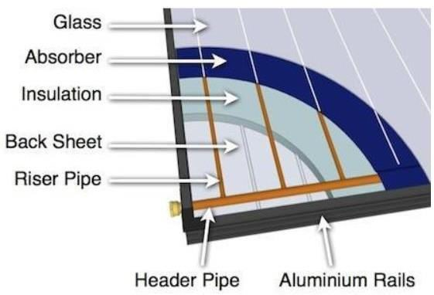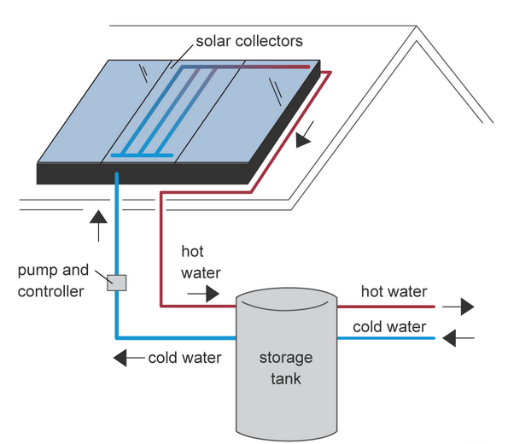

**Fig: Solar Thermal Collector**

Thermosiphon Solar Water Heater**:** Thermosiphon is a technique for aloof warmth trade, in view of characteristic convection, which circles a liquid without the need of a mechanical siphon. As the liquid goes through a high-temperature increment, thermo-siphon frameworks ordinarily have low stream rates through the gatherer. The terrible showing of thermo-siphon frameworks represents this.

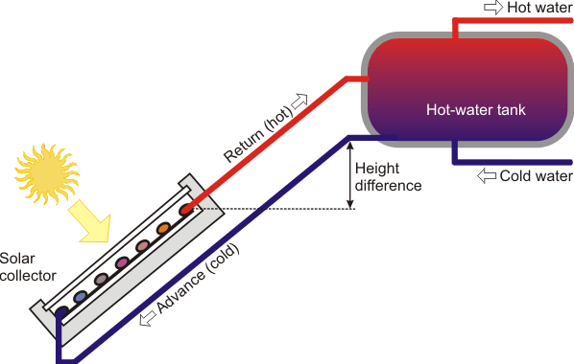

**Fig: Thermo-siphon Solar Water Heater**

Flat Plate Collector: FPC is based on Solar Water Heaters. The sunlight-based radiation is consumed by Flat Plate Collectors which comprise of a protected external metallic box covered on the top with glass sheet. Inside there are darkened metallic safeguard (specifically covered) sheets with worked in channels or riser cylinders to convey water. The safeguard assimilates the sun powered radiation and moves the warmth to the streaming water.

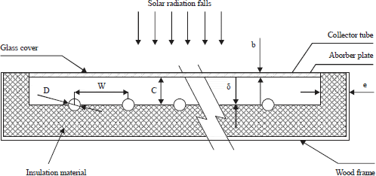

**Figure 2: Solar Flat Plate Collector**

**Solar thermal system advantages:**

* Reduce energy bills, cost savings: up to 60% less energy to heat water, up to 35% less energy for space heating
* Become eco-friendly
* Reduce your carbon footprint
* Reduced consumption of fossil fuels
* Improve home power efficiency
* Take advantage of the efficiency of renewable energies without forgoing the elegant, sophisticated design of a natural slate roof

**Solar thermal system disadvantages:**

* The initial cost of purchasing a solar system is fairly high
* Solar energy can still be collected during cloudy and rainy days, the efficiency of the solar system drops
* Solar energy storage is expensive
* Uses a lot of space
* Associated with pollution.

**Working Principle:**

The essential guideline of solar thermal system is to use the sun's energy and convert it into heat which is then moved into your home or business warming framework as boiling water and space warming. In a run of the mill sun-based water radiator, water is warmed by the sun based nuclear power consumed by the authorities. The boiling water with lower thickness moves upwards and cold water with higher thickness drops down from the tank because of the gravity head. A bank of authorities can be masterminded in an arrangement equal blend to get a higher amount of heated water. A regular 100 liters protected tank with a 2 m2 authority territory, will supply water at a temperature of 60-80°C. Sun based nuclear power can be utilized for such applications as, space warming, cooling, boiling water, mechanical cycle heat, drying, refining and desalination, and electrical force

**Methodology:**

The capacity was loaded up with 100 liters of water and working liquid cylinders were loaded up with working liquid through the working liquid reservoir. The working liquid is provided from the working tank which streams inside the cylinders in the authorities and afterward to the sun-oriented water stockpiling tank. A part of frequency sun-oriented radiation on the glass cover is reflected back to air and remaining is communicated inside the sun-oriented authorities and the sunlight-based radiation is consumed by the working liquid. Because of the ingestion of sunlight-based radiation, working liquid temperature increments also, the working liquid beginnings producing long frequency radiation which isn't permitted to departure to air because of essence of glass cover. Consequently, the temperature over the working liquid inside the sun powered gatherers gets higher. The protection gave at the base what not the sides of sun-oriented gatherers and glass cover effectively reduces direct convective misfortunes to the surrounding which further gets helpful for ascend in working liquid and sun-oriented gatherers temperature separately. The warmed working liquid moves upward because of decline in thickness while the colder working liquid settled at the lower parcel because of additional in thickness. Following 3 hours the temperature of water (working liquid) at outlet is estimated.

**Conclusion:**

In this experiment we have learned about solar thermal system. As its software-based lab for this we covered all theoretical aspects of this experiment. We learned all this component working principle by watching video and animations and reading all through lab manual. More all less we have successfully understood all those aspects and working principles of solar thermal system.